Cara Print SOP

By

Rolando Manso

This SOP is meant only for those who have been previously trained by proficient members of TSD’s CAM team.

Open Cara nesting software to begin.

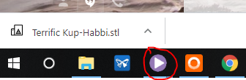

This opens the print manager.

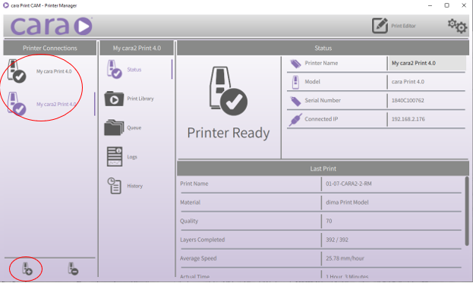

It may be necessary to connect to the printers if they are not visible in the upper left-hand corner. We connect by clicking on the plus sign in the bottom left hand corner. The IP address from the printer will be required for connection (192.168.2.175 & 192.168.2.176). Please refer to your training.

Click the print editor symbol in the top right-hand corner of the screen.

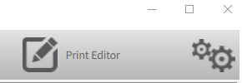This brings up the print editor.

Click the “Add” button to nest STL files.

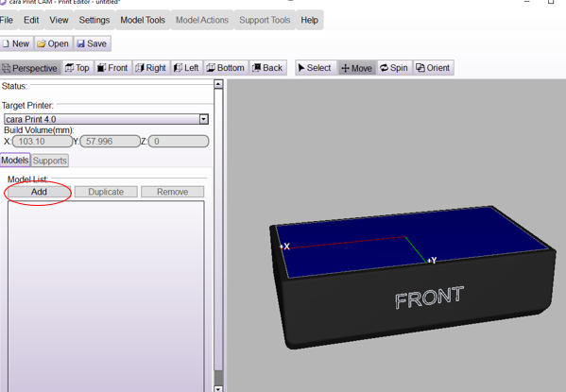

Choose the appropriate files.

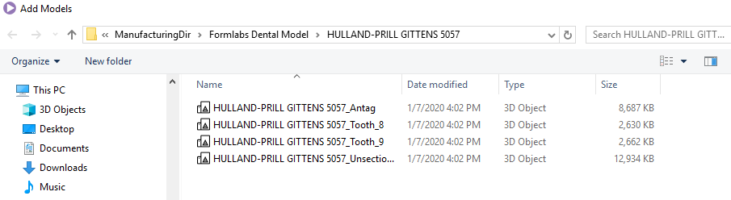

\*Solid = unsectioned (sic) model – Full & Quad = all files – always print all dies\*

Click on the “Supports” tab and then the “Support Tool” to add supports to the model.

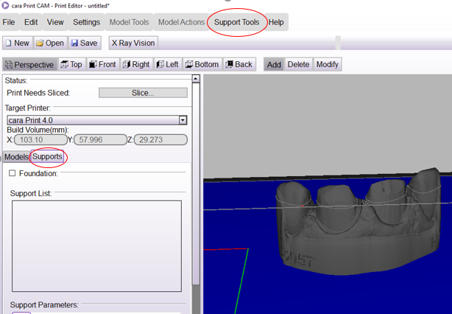

Click on “Automatic Supports”.

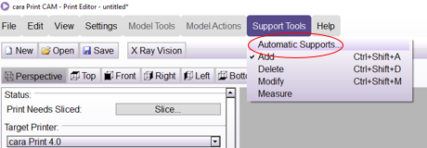

Verify support density is 50% and click “Generate Now”.

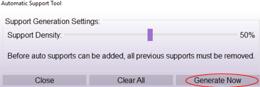

Inspect your model for stray supports and delete them via right click and delete support.

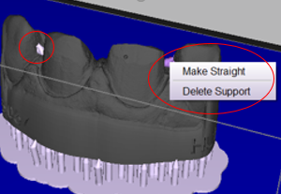**\*\*\*No supports may be on margins\*\*\***

Save per the proper naming convention as trained.

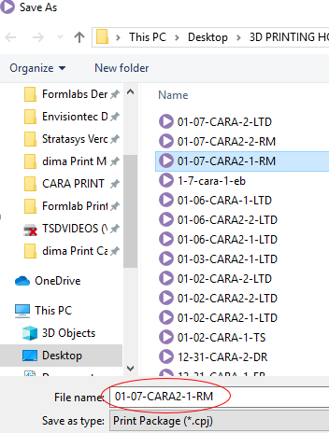

Upon successful save, slice the model by clicking slice.

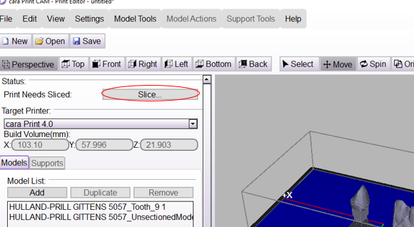

Upon completion of the slicing process, upload the prints to the appropriate printer by clicking “Upload to printer”.

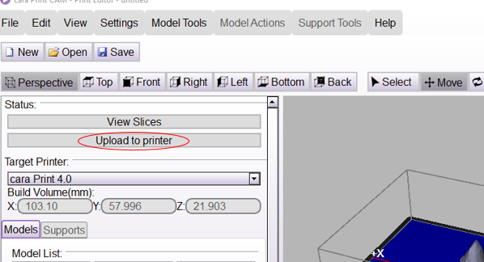

Then choose your printer and click “upload”.

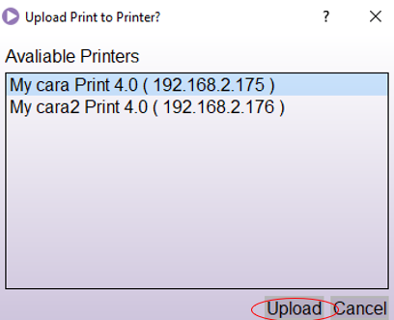

At the printer, start the print per your training.

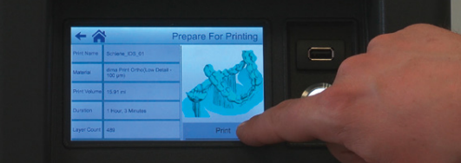

Upon completion of printing process, post process per your training using automated alcohol baths for 3-minute rounds.

Cure in Cara HiLite cure for 5-minute rounds (2 rounds with models flipped in between per training).

If you have questions about anything, stop and ask. Verify proper fit, cleanliness, and final quality of the models prior to allowing any of them to leave the CAM area. All dies go in small baggies with the case number written on the bag.